Car Wash Management System

# Gruppe Kontrakt

**Gruppe:** Joachim, Nikolaj, Ronny og Silas.

1. Kommunikation foregår over intern Facebook gruppe.
2. Regler:
   1. Hvis man kommer over 10 minutter senere end den aftale tid, skylder man gruppen “kage”.
   2. Ingen dårlige undskyldninger.
   3. Udeblivelse tilgodeses kun hvis gruppen accepterer det.
3. Gerne brug 1 lille time, på opgaven, efter undervisningen et par gange i løbet af ugen.

# Use Cases

Title: Buy WashCard

Actor: Customer

## Scenario:

The customer inserts his credit card and chooses “Buy Washcard”. He then enters his surname, lastname and the amount he wants to add to his new washcard. The amount of money he can add must be between 200-1000kr. Afterwards he creates a password for future use. The system prints out the customer's information and asks if he want to login or quit.

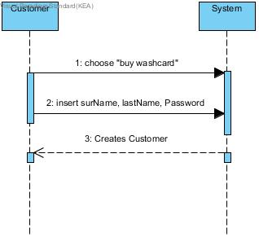

Title: Buy Car Wash

Actor: Customer

## Scenario:

The Customer logs on and chooses “Wash car”, followed by the desired wash. Money will now be withdrawn from his washcard. He can now choose if he wants a receipt or not. If his balance is too low to buy the desired wash, the system will tell him that he’s low on credit, and it will return the original 4 options.

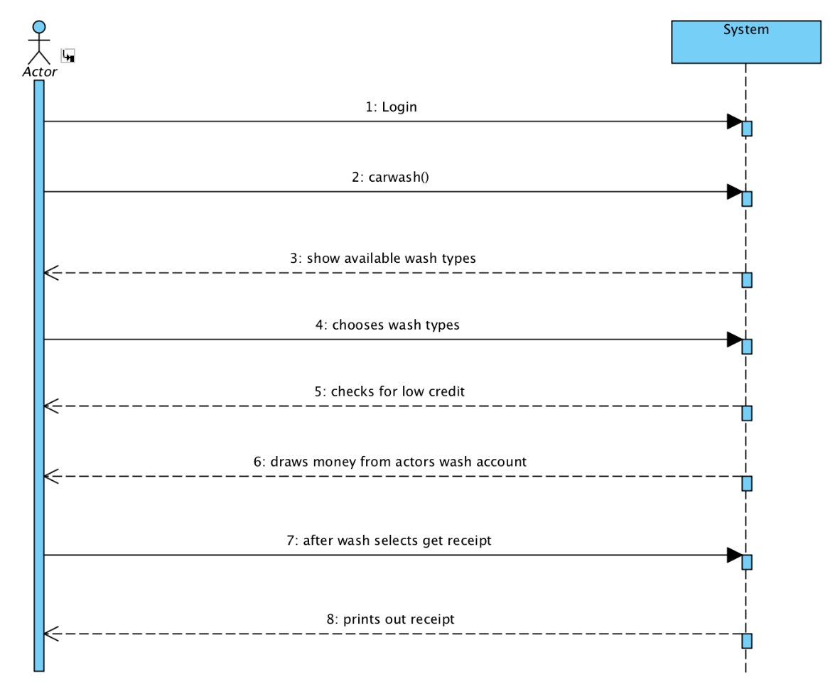

Title: Refill Washcard

Actor: Customer

## Scenario:

The customer inserts Washcard and enters the login information. Then chooses to re-fill and indicates the amount he wishes to deposit. The maximum deposit amount is 1000 kr. If the balance exceeds 1000kr, then more cannot be deposited. After depositing, the balance is displayed and returns to the main menu with 4 options.

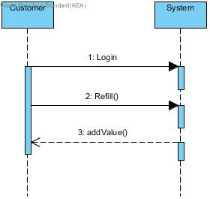

Title: Get Washcard balance

Actor: Customer

## Scenario:

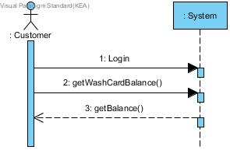The Customer logs into the system, chooses “Get your balance” and the system tells the current balance.

Title: Statistics

Actor: Owner

## Scenario:

The Owner quits the Car Wash and logs into the statistics. The Owner is now shown each wash the customers have bought.

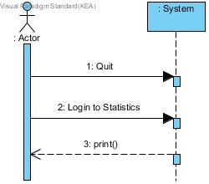

## LIST:

**Noun list:** The System, Customer, Washcard, Receipt, Balance, Statistics, Wash.

**Verb list:** insert, buy, chooses, tells, checks.

# Domain Model:

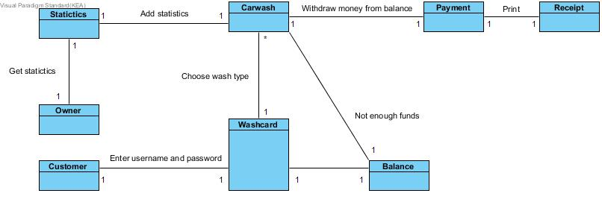

# **Class Diagram1.jpg**Class Diagram: